### Semester Two Examination, 2023

### Question/Answer booklet

# 12 SPECIALIST MATHEMATICS

**UNIT 3**

## Section Two:

## Calculator-assumed

Your Name _______________________________

Your Teacher’s Name _________________________

## Time allowed for this section

Reading time before commencing work: ten minutes

Working time: one hundred minutes

## Materials required/recommended for this section

***To be provided by the supervisor***

This Question/Answer booklet

Formula sheet (retained from Section One)

***To be provided by the candidate***

Standard items: pens (blue/black preferred), pencils (including coloured), sharpener, correction fluid/tape, eraser, ruler, highlighters

Special items: drawing instruments, templates, notes on two unfolded sheets of A4 paper, and up to three calculators approved for use in this examination

## Important note to candidates

No other items may be taken into the examination room. It is **your** responsibility to ensure that you do not have any unauthorised material. If you have any unauthorised material with you, hand it to the supervisor **before** reading any further.

|  |  |  |  |  |  |
| --- | --- | --- | --- | --- | --- |
| **Question** | **Marks** | **Max** | **Question** | **Marks** | **Max** |
| **7** |  | **4** | **16** |  | **7** |
| **8** |  | **10** | **17** |  | **6** |
| **9** |  | **11** | **18** |  | **8** |
| **10** |  | **5** | **19** |  | **9** |
| **11** |  | **5** |
| **12** |  | **13** |
| **13** |  | **6** |
| **14** |  | **6** |
| **15** |  | **7** |

**Structure of this paper**

|  |  |  |  |  |  |
| --- | --- | --- | --- | --- | --- |
| Section | Number of questions available | Number of questions to be answered | Working time (minutes) | Marks available | Percentage of examination |
| Section One:  Calculator-free | 6 | 6 | 50 | 48 | 33 |
| Section Two:  Calculator-assumed | 13 | 13 | 100 | 97 | 67 |
|  |  |  |  | **Total** | 100 |

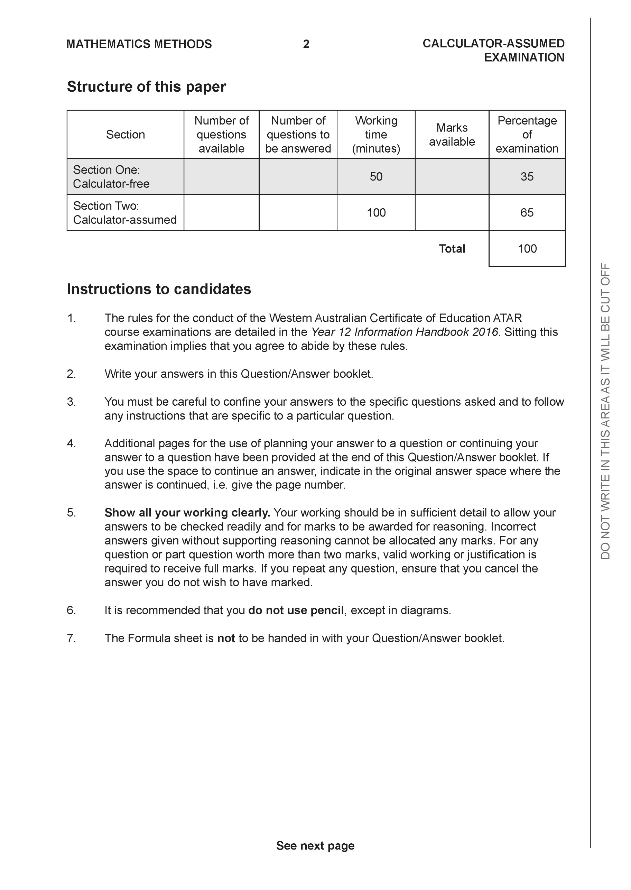

**Section Two: Calculator-assumed (97 Marks)**

This section has **13** questions. Answer **all** questions. Write your answers in the spaces provided.

Spare pages are included at the end of this booklet. They can be used for planning your responses and/or as additional space if required to continue an answer.

● Planning: If you use the spare pages for planning, indicate this clearly at the top of the page.

● Continuing an answer: If you need to use the space to continue an answer, indicate in the original answer space where the answer is continued, i.e. give the page number. Fill in the number of the question that you are continuing to answer at the top of the page.

Working time: 100 minutes.

**Question 7 (4 marks)**

Consider a ladder placed with one end, point A, on a wall and the other, point B, on the floor as shown below. The ladder has a length of 5 metres and point B is moving towards the wall at a speed of 3 metres per minute. When point B is 4 metres from the base of the wall, determine the speed of point A which is moving up the wall.

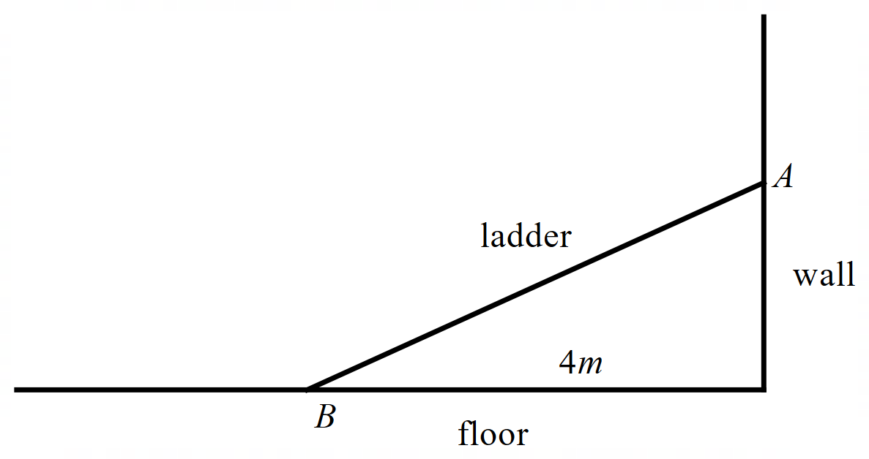

**Question 8 (10 marks)**

1. Consider the locus  in the complex plane.

Determine the following:

1. Minimum Arg(z). (3 marks)
2. Maximum . (2 marks)
3. Sketch the following locus  on the axes below. The Arguments in this locus lie between the following . Determine the values of .

(5 marks)

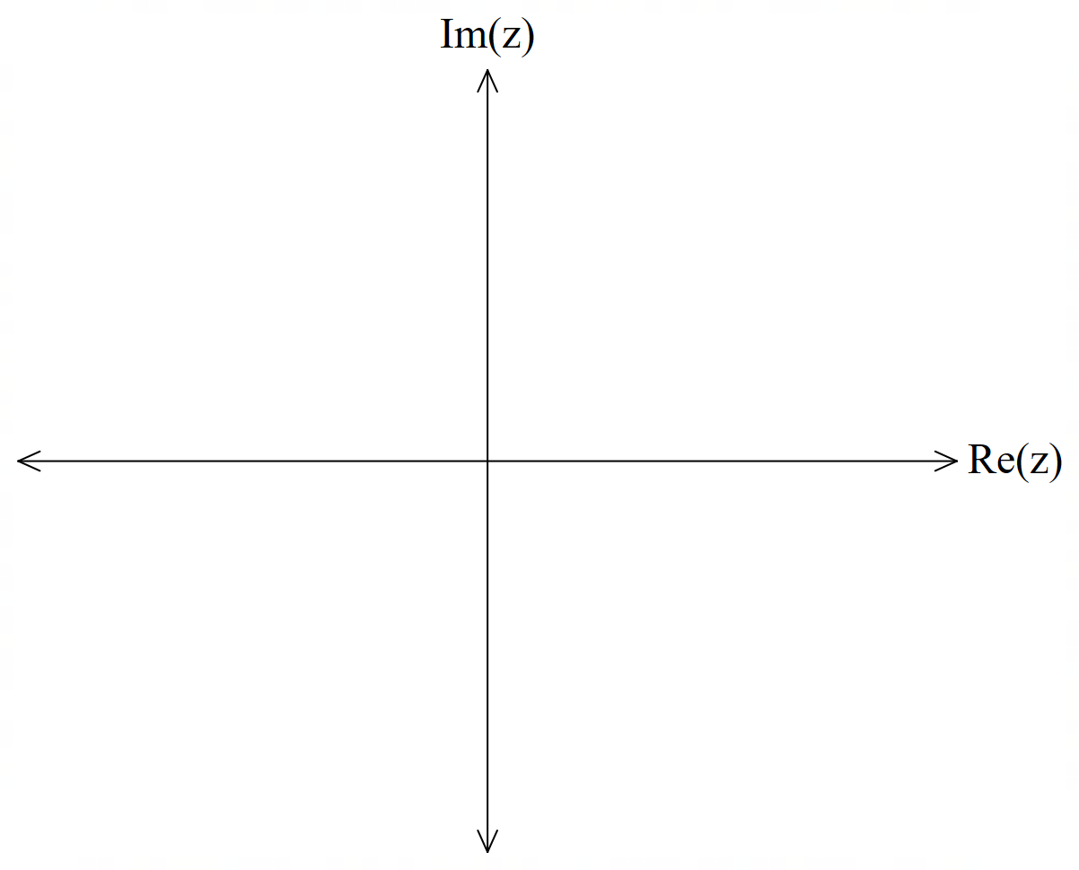

**Question 9 (11 marks)**

Consider a racing car that travels in a racecourse with velocity  at time  hours. The initial position is . (See diagram below).

1. Determine the acceleration at  hours. (2 marks)
2. Determine . (3 marks)

Q9 continued on next page

1. Determine the length of one track of the racecourse. (3 marks)
2. Determine the cartesian equation of the path of the race car. (3 marks)

**Question 10 (5 marks)**

Consider a particle that undergoes motion defined by  with ,metres being the displacement at time,  seconds. The velocity is zero when  metres.

Determine the percentage of time that the particle has a speed less than half of its maximum speed.

**Question 11 (5 marks)**

(a) Determine the solutions to in polar form and plot them on the Argand plane below. Label the solutions , , , , and in an **anti-clockwise** direction, starting from which is on the positive real axis. (3 marks)

**<EFOFEX>

id:fxd{4a597148-0010-42e6-ad05-f7fb6339c2d6}


FXData:


</EFOFEX>**

(b) There is a cubic polynomial with real coefficients whose roots are , and .  
Write down this cubic polynomial in the form . (2 marks)

**Question 12 (13 marks)**

Given the points , , and .

(a) Determine the vector equation of the line through the points and . (1 mark)

The vector equation of the line through and is .

(b) Determine the Cartesian equation of the plane, , containing the lines passing  
through and . (2 marks)

(c) (i) Show that , , and are coplanar. (2 marks)

(ii) Prove that is a rectangle. (2 marks)

A sphere is constructed with its centre on plane from part (b).

(d) Determine the vector equation of this sphere if , , and lie on the surface. (3 marks)

A set of three planes is given as follows:

(e) Determine the value of such that the above planes only intersect at the  
centre of the sphere found in part (d). (3 marks)

**Question 13 (6 marks)**

(a) By using partial fractions, show that:

(2 marks)

**<EFOFEX>

id:fxd{47d9f0dd-dd09-4a8a-9724-9f44c1a37b3e}


FXData:

</EFOFEX>**

On a coordinate plane, a point moves along a path, such that after

seconds , the position of the point is defined by

The direction of motion is shown in the diagram on the right.

(b) Determine when the angle between the direction of motion and the positive direction  
 of the -axis is . (4 marks)

**Question 14 (6 marks)**

(a) By letting and , prove . (1 mark)

(b) By letting , use De Moivre’s theorem to prove that . (1 mark)

(c) A polynomial is divided by , where is a  
 complex number, leaving a remainder of .

(i) Using parts (a) and (b), show that the remainder when is divided  
 by is . (3 marks)

(ii) If for all solutions of , it is known that , where is a complex

number what can be said about the coefficients of ? (1 mark)

Question 15

(7 marks)

<EFOFEX>
id:fxd{7462c59f-8bdf-4163-8c53-8af1f7f8d30a}

FXData:
</EFOFEX>The slope field for the differential equation

where is a constant, is shown at right.

(a) Use a feature of the slope field to explain why and hence determine the slope at the point . (2 marks)

(b) Determine the solution of the differential equation that contains the point in the form . (4 marks)

(c) Sketch the solution curve that contains the point on the slope field. (1 mark)

**Question 16 (7 marks)**

<EFOFEX>
id:fxd{c0a07404-534d-4fd4-afde-f5518418e4e2}

FXData:
</EFOFEX>(a) Use the substitution to show that ,  
where is a constant of integration. (4 marks)

(b) The equation of the curve shown is  
  
.

Determine the area enclosed by the  
curve and the line . (3 marks)

Question 17 (6 marks)

Consider the function , where and are positive constants.

The graph of cuts the -axis at , has a horizontal asymptote with equation and has a vertical asymptote with equation .

(a) Determine . (3 marks)

(b) Now consider the graph of . State the

(i) equation of its horizontal asymptote. (1 mark)

(ii) -axis intercepts. (1 mark)

(iii) equations of its vertical asymptotes. (1 mark)

Question 18 (8 marks)

A machine fills bags with sugar. The mean and standard deviation of the weight of sugar it delivers into a bag is and grams respectively. An inspector routinely takes a random sample of bags filled by the machine.

(a) For repeated random sampling of bags of sugar filled by this machine, state the approximate distribution of the sample mean that the inspector should expect. (3 marks)

(b) Determine the probability that the mean weight of a random sample of bags of sugar is at least grams, given that the sample mean is less than grams. (2 marks)

(c) Occasionally, the inspector only has enough time to take a random sample of bags. In the long run, of sample means derived from samples with this smaller size will lie in the range grams. Determine the value of . (3 marks)

Question 19 (9 marks)

(a) Plot the complex number that satisfies the conditions and on the Argand diagram below. (2 marks)

<EFOFEX>
id:fxd{aecc4253-2e5b-4722-9a70-db3592a96c42}

FXData:

</EFOFEX>

(b) Let and be another complex number. The locus of a complex number satisfies the condition and is shown in the diagram below.

<EFOFEX>
id:fxd{4c0be6a6-ead6-49b1-8fd0-59bc376d970c}

FXData:

</EFOFEX>

(i) Determine the complex number . (2 marks)

(ii) On the same diagram, indicate the locus of a complex number that satisfies the condition . (1 mark)

(c) The locus of points that satisfy is an arc of a circle.

(i) Sketch the locus of in the complex plane. (2 marks)

<EFOFEX>
id:fxd{928e6a15-a0f9-4894-9659-4cf91259c7ae}

FXData:

</EFOFEX>

(ii) Determine, with justification, the exact location of the centre of the circle.

(2 marks)

**Working out space**

Additional working space

Question number:

Additional working space

Question number: